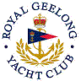 | Royal Geelong Yacht Club Inc.  Est 1859
Trophy Deed of Gift.

Trophy: | House Committee Perpetual Shield
Presented by: | “House” Committee
Date: | 1948
For: | “B” Class Aggregate Winner
Remarks / Revisions | No Longer awarded
Editor’s Note
Prior to the Club appointing paid staff, the operations of the Club were overseen by various sub-committees, one of which was the ‘House Committee’. Its purpose was to manage the operations of the ‘House’ including social functions and Bar.. Most of its activities are now performed by the Front-of-House manager.

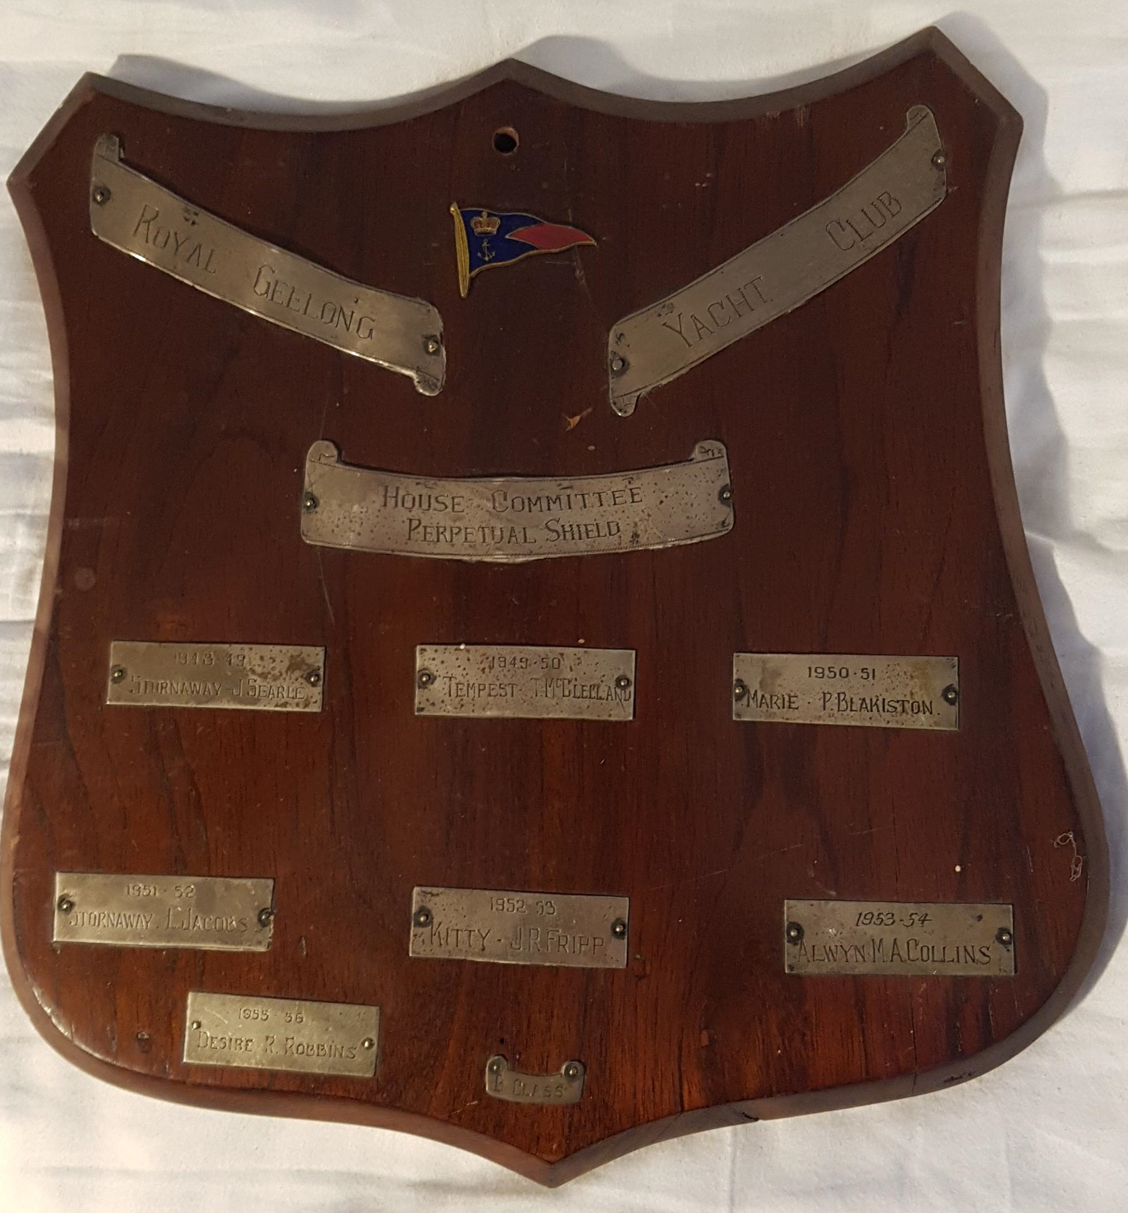

Recipients
1948-1949 | Stornaway | Jim Searle
1949-1950 | Tempest | T. McClelland
1950-1951 | Marie | Peter Blakiston
1951-1952 | Stornaway | L. Jacobs
1952-1953 | Kitty | J. R. Fripp
1953-1954 | Alwyn | M. A. Collins
1954-1955
1955-1956 | Desire | Robin Robins

